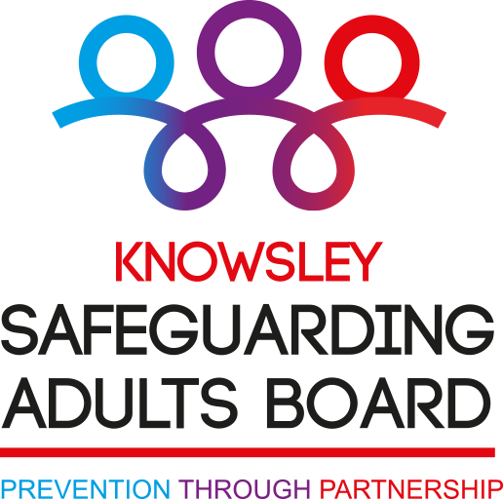

The Self-Neglect and Hoarding Toolkit:
A Guide to Working with People in Circumstances of Complex Self-Neglect and Hoarding

Written by practitioners, for practitioners

November 2022

The Self-Neglect and Hoarding Toolkit
A Guide to Working with People in Circumstances of Complex Self-Neglect and Hoarding

Who is it for?
For all professionals working in complex self-neglect situations.

What is it designed to do?
- To help you to assist the person you are working with to improve their circumstances.
- To give you suggestions about what you can do in difficult situations, based on the experience and insights of other professionals in Merseyside, including Knowsley, working with people who self-neglect.
- To make sure you, and all the other agencies you work with, have tried everything you possibly can.
- To help you put together the pieces of the multi-agency puzzle.
- To help you make defensible decisions.

With thanks to:
- The many staff from many different agencies, across Knowsley, Liverpool, Wirral and Sefton, who came to the self-neglect workshops held at Liverpool John Moores University during 2018. Discussions and ideas from these workshops led to the original guide being compiled.
- Knowsley staff who contributed to extending and enhancing the guide in May 2022.
- Merseyside and Salford Hoarders Helping Hoarders Psychosocial Intervention & Peer Support Groups, who read, commented on, and made valuable additions to this guide.

Contents
Foreword 1
Overview – the current context of ‘self-neglect’ work 2
Part 1: Setting the scene 3
Useful things to remember when working with complex cases of self-neglect and hoarding 3
Myth busting about self-neglect and what agencies can do 4
What can different agencies do for people who self-neglect? 5
Professional hopes and service user fears 7
What professionals think service users might hope for: 7
What service users fear will happen when professionals enter their lives: 8
The Mental Capacity Act 2005: 11 pointers from practitioners 9
Executive and decisional capacity – exploring this further with people who self-neglect 10
Suggestions from practitioners about how this could be done 10
‘Have you tried?’ 11
Before you go out, think about: 11
When you go out: 11
If you fail to get in: 11
Have you tried? (continued) 12
Introduction: 12
When you are doing your assessment: 12
Practical support: 12
Part 2: Working with self-neglect: supporting people towards self-care 13
Targeting efforts 13
Utilities 13
How to proceed 14
Targeting support: 14
Task – Equipment – Abilities - Expertise – Alternatives 14
Washing the body 16
Continence care 17
Dental care 18
Hair and nail care 19
Dressing 20
Eating 21
Drinking 22
Healthcare 23
Health care and mental capacity 24
Odour 24
How to fund these suggestions 25
Part 3: Hoarding 26
Getting rid of stuff can be very difficult to do 26
How do practitioners get rid of stuff themselves? 27
What can hinder getting rid of things? 27
What are our reasons? 27
How can we help people who hoard get rid of stuff? 28
Practically: 28
Emotionally: 28
The Mental Capacity Act and Hoarding 29
Part 4: Domestic neglect 30
Making external help more acceptable 30
Part 5: Severe domestic squalor: Maslow House 31
First things first: Focusing on physiological needs 32
Best practice with people who don’t want to engage with services 33
When to keep the person’s case open 34
Points to consider when deciding whether to keep a complex self-neglect case open to a worker 34
How to decide whether to keep a complex case open 35
How to get in touch with us 37

Foreword

“As Independent Chair of the Knowsley Safeguarding Adult’s Board, I am pleased to introduce this updated Practice Guide for colleagues of all agencies working with people who self-neglect within the Boards area. The first version of this guide was produced in 2018 with help from a wide range of colleagues and with people who self-neglect, and we have followed a similar process this time. I hope you find the Guide helpful, and that it is relevant to your day to day work.
Responding to self-neglect can be a complex and difficult area of your work, and there has been a range of academic interest in the causes of, and outcomes for, people who self-neglect. But what I have been again encouraged by is some of the very practical suggestions within this updated Guide, as well as the shared sense of purpose by a wide variety of agencies to try to engage and improve the wellbeing of people who self-neglect.
I have also been impressed by the way in which colleagues from different agencies have recognised that the challenges they experience individually in working with people who self-neglect, are shared across many agencies, and that it is only by working together in partnership that we can really make a difference.
I know that one of the challenges of working with people who self-neglect can be your own agencies processes, as understandably resources and time can be limited by the demands placed on each of your organisations, but I hope that this Guide gives you confirmation that you are not alone, and gives you confidence in conversations with your colleagues and managers about what helps when you are trying to engage with someone who self-neglects.
In developing this Guide, I was mindful that the Safeguarding Adult Board has a responsibility to prevent abuse and neglect in its area and to understand the experiences of staff working with people who self-neglect, and while I acknowledge that each of your organisations will have its own procedures and processes, it is an expectation that these will be compatible with this Guide”.

Sue Redmond
October 2022

Overview – the current context of ‘self-neglect’ work

The Care Act 2014 includes self-neglect as a safeguarding issue. The term ‘self-neglect’ is perhaps not a very helpful one in practice, because it is really an umbrella term for some very different presentations. Self-neglect is fundamentally about neglect of the physical body. This is very different from hoarding, though the two may co-exist. Many people who have issues with hoarding have no problems with self-neglect. However, self-neglect and hoarding may lead to domestic neglect, and ultimately to severe domestic squalor.

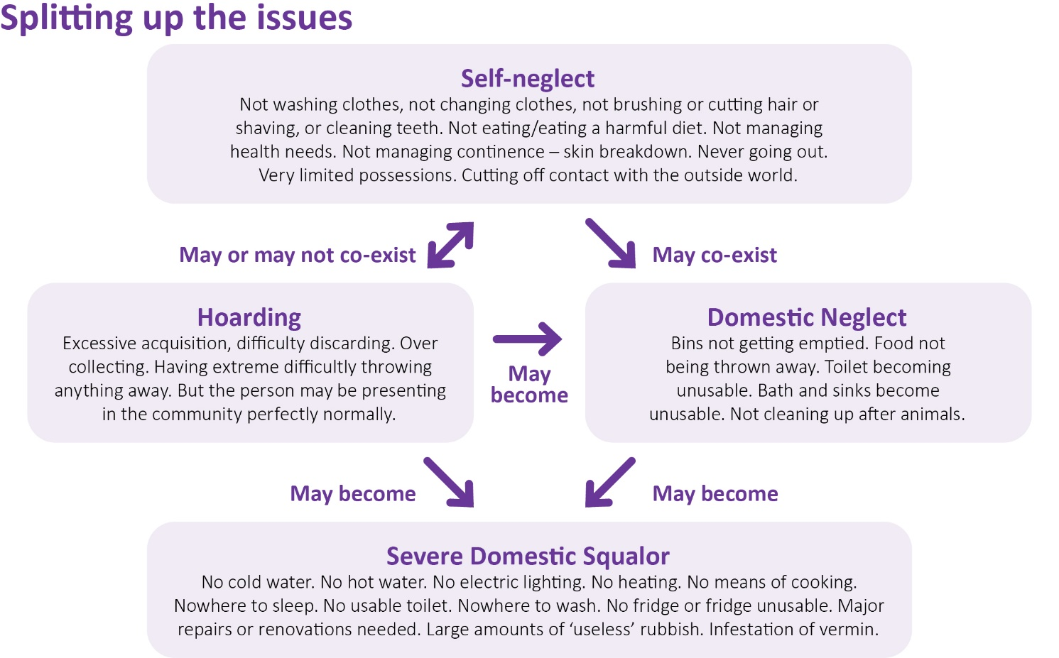

E Aspinwall-Roberts, 2022

Breaking things down in this way can be helpful to agree priorities with the person themselves, and in working with other agencies. It can also help to stop you feeling overwhelmed by the sheer complexity of some situations that you might come across. In this guide, the catch-all umbrella term ‘self-neglect’ is used when we’re looking at general issues, such as what different agencies do. But you will also find separate sections with ideas for working with each of the above as separate areas.

One point to consider that might have an impact on the above areas is housing tenure – who owns the property the person lives in? Does the person themselves own it, are they a tenant of a private landlord, or a registered social landlord? This can sometimes limit what can be done, or dictate what legally will have to be done, for example, where a person’s actions may be putting other tenants at risk.

Part 1: Setting the scene

Useful things to remember when working with complex cases of self-neglect and hoarding

What are the sorts of principles and ideas that can usefully guide work with people who self-neglect?

- Start with kindness – professional kindness is powerful and needed here.
- Show curiosity, interest and concern about people’s welfare.
- Relationship building is crucial. Be patient and work at their pace.
- Find out what the person wants and expects, and what is worrying them, see if they feel able to cope or resolve some things for themselves.
- Identify whether any risks (or worries) require immediate action – what is the duration and seriousness of the self-neglect. Are the problems low, medium or high risk?
- Try to understand the history of how they came to be self-neglecting, and their worldview – what is their life like? Consider trauma, bereavement, loss, divorce. Be aware of any diversity issues.
- At the right point be open and honest with the person (particularly about what your worries are about them). Reinforce the positive aspects of their life.
- Identify the supports that might be out there for them.
- Offer choices, but don’t make promises you can’t keep, don’t over-promise.
- Call a case conference or professionals meeting early in the process. Share the risk.
- Everyone (including you manager) needs to understand that persistence and commitment require time.
- Work on shared goals, not goals based on how you think they should live.
- Proportionality is everything. Don’t use a sledgehammer to crack a nut.
- Persist, don’t give up, keep going back, but make sure your involvement is lawful.
- Liaise with other professionals, and where possible the adult’s family and friends, give thought to who else could usefully be involved.
- Negotiate ‘quick wins’ for the person – possibly leading to ‘bargaining’.
- Remember human rights!
- The term ‘self-neglect’ can be perceived as a very stigmatising and emotive term – be careful how you use it.

Myth busting about self-neglect and what agencies can do
Self-neglect seems to be an area of work where it’s easy to make assumptions about what other agencies can and can’t do, and this can lead to conflict. Here, practitioners describe the myths and truths about their roles, powers and boundaries.
MYTH | TRUTH
We (social worker, nurse, occupational therapist etc) can wave a magic wand | We can help but the person needs to engage with what is offered
Medication and therapy can provide a quick solution | Improving well-being, quality of life or neglectful behaviour can take a long time
Safeguarding will sort everything out (‘an easy referral can make this person safe’) | It’s a team effort. It requires a multi-agency approach to work with complex cases
If a safeguarding referral is made, the social worker can enter a person’s home and remove people from their property | Social workers are unable to remove someone from their property without consent or a court order or legally prescribed process
People can be forced to engage in personal care tasks and have support from care agencies. Staff can ‘just do it’ for the person. | A person must consent to personal care being undertaken.
Self-neglect is all about hoarders | Self-neglect includes lots of other factors. Many people who hoard don’t self-neglect at all
If a person refuses help, such as with de-cluttering of clearing we can force them to accept it | It is all about negotiation and understanding why they are saying no, and an attempt to reach a shared goal so some support can be delivered, and the risk reduced
Social workers can over-ride someone’s decision when they have capacity, if they think the person is making an unwise decision. | They can’t nobody can. Just because a person makes a decision that we think is unwise, doesn’t mean they are incapable of making that decision.
Social workers have powers of surveillance | They don’t
Only doctors can assess mental capacity | A range of people can assess capacity
Patients cannot be discharged from hospital if their property is in a poor state | They can
If we clean the house out, the problem will be sorted | The behaviour probably won’t change
Self-neglecting people are lazy and it’s a ‘lifestyle choice’ | Situations can be very complex. It may be choice in some elements of the adult’s situation but not necessarily all

What can different agencies do for people who self-neglect?

It can be really confusing to work out who does what in self-neglect cases. This is how all the agencies who helped compile this guide see their role.

Clinical psychologists can support people who self-neglect by developing a psychological understanding of their situation and helping them to find strategies to help manage their situation, including psychological therapy

Community nurses provide healthcare to people in their own homes. They will refer to other services, such as the Continence Service, or for specialist equipment like hospital-type beds.

Environmental Health aim to reduce the risk to the self-neglecting person themselves but also to the community, through practical direct work with the person, invoking relevant legislation where necessary.

Fire & Rescue Services can provide fire safety advice and put practical measures in place to reduce the risk of a fire. They may refer on to other agencies for more support.

General Practice staff can identify people who seem to be self-neglecting, provide support, and refer to other agencies to enable people to get support and help if required and consented to.

Hospital nurses will identify patients who seem to be self-neglecting, support the patient, and refer to other agencies to enable patients to gain help and support if required and consented to whilst in hospital.

Housing staff can help people very practically to support their tenancies if they are at risk of being evicted because of problems with self-neglect or hoarding.

Independent Advocates support the person to make their own decisions, ensures their views, wishes, feelings, beliefs, and values are listened to, and may challenge decisions that they feel are not in the person’s best interests.

Occupational therapists work with individuals to identify any difficulties they experience in day to day living activities, and finding ways to alter or solve them. They support independence where possible and safety within the community, and build confidence and motivation.

Paramedics are called by the patient or a third party caller due to medical concerns or health deterioration. They will deliver appropriate emergency treatment, assess mental capacity in relation to the health issues presented (particularly if a person is refusing to go to hospital), and refer on to other agencies with concerns.

Physiotherapists can help with treatment of injury, disease, and disorders through physical methods. A physio helps and guides patients, prescribes treatment and orders equipment.

Police can investigate and prosecute if there is a risk of wilful neglect, they can provide safeguarding to families and communities by sharing information, refer to specialist partner agencies, and use force to gain entry/access if there are legal grounds to do so. The Police Community Support Officers Early Help Team will refer to other agencies and signpost.

Probation case managers will identify problems via home visits and provide regular monitoring. They may refer on to social services, mental health services, housing, health etc. They will complete risk assessments and risk management plans, making links to the risk of serious harm.

RSPCA will investigate complaints of cruelty and neglect to animals and offer support and advice.

Social workers will complete an assessment by taking to and getting to know the person. They may establish their mental capacity to make decisions about their lives, look at all of the options. They may put in a package of care, or refer to other agencies for the services that they provide (for example, to fire services for a fire safety check). They might arrange multi-agency meetings to discuss concerns and ways forward. They can help with relationship building and communication skills, and try to develop support networks.

Voluntary, Community and Faith Sector (VCFS) staff and volunteers can provide a whole range of social opportunities and support services that can connect people with their communities, e.g., luncheon clubs, support groups, health advice, furniture recycling, food banks, advocacy etc. Staff and volunteers can be a key part of formal as well as informed plans and support.

Finally, there are other Allied Health Professionals who may play a part. People such as incontinence nurses, falls nurses, dieticians, speech and language therapists. They aren’t usually the first people to be involved, but may have a really important role to play.

Professional hopes and service user fears

It’s easy to think that professionals and service users/patients are all ‘on the same page’ as each other when they are working together. In reality (and with great thanks to the service users who gave their ideas for the ‘Fears’ diagram), it’s very sobering to see the difference between what professionals think adults who self-neglect and hoard might hope for, and what service users themselves might fear.

What professionals think service users might hope for:

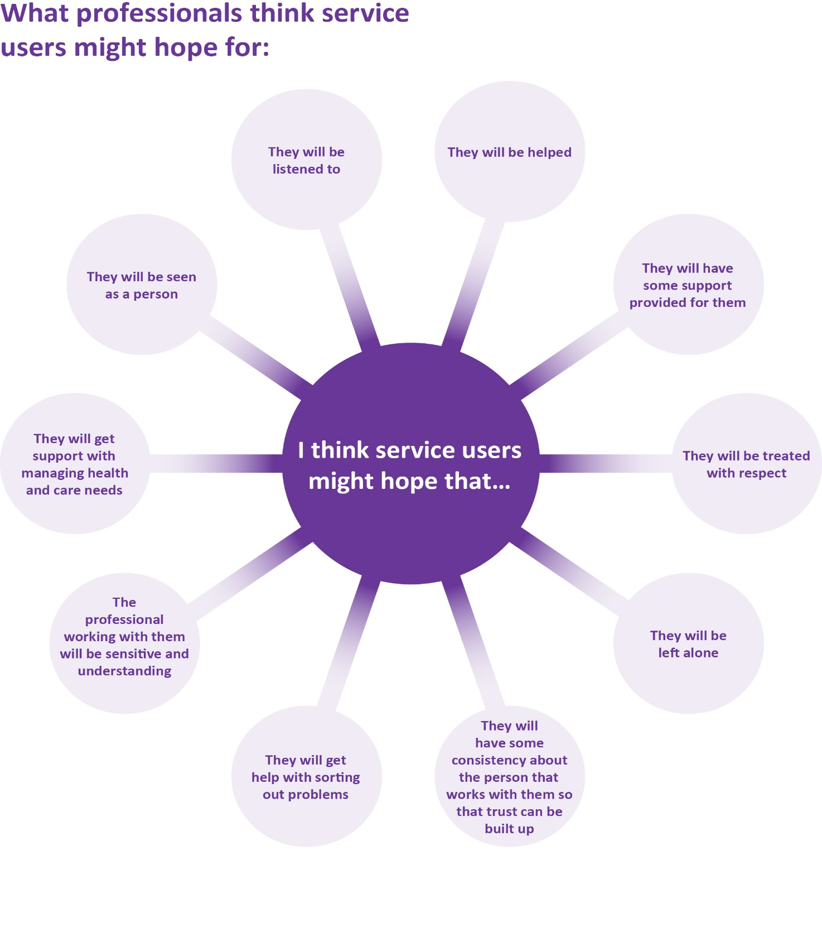

What service users fear will happen when professionals enter their lives:

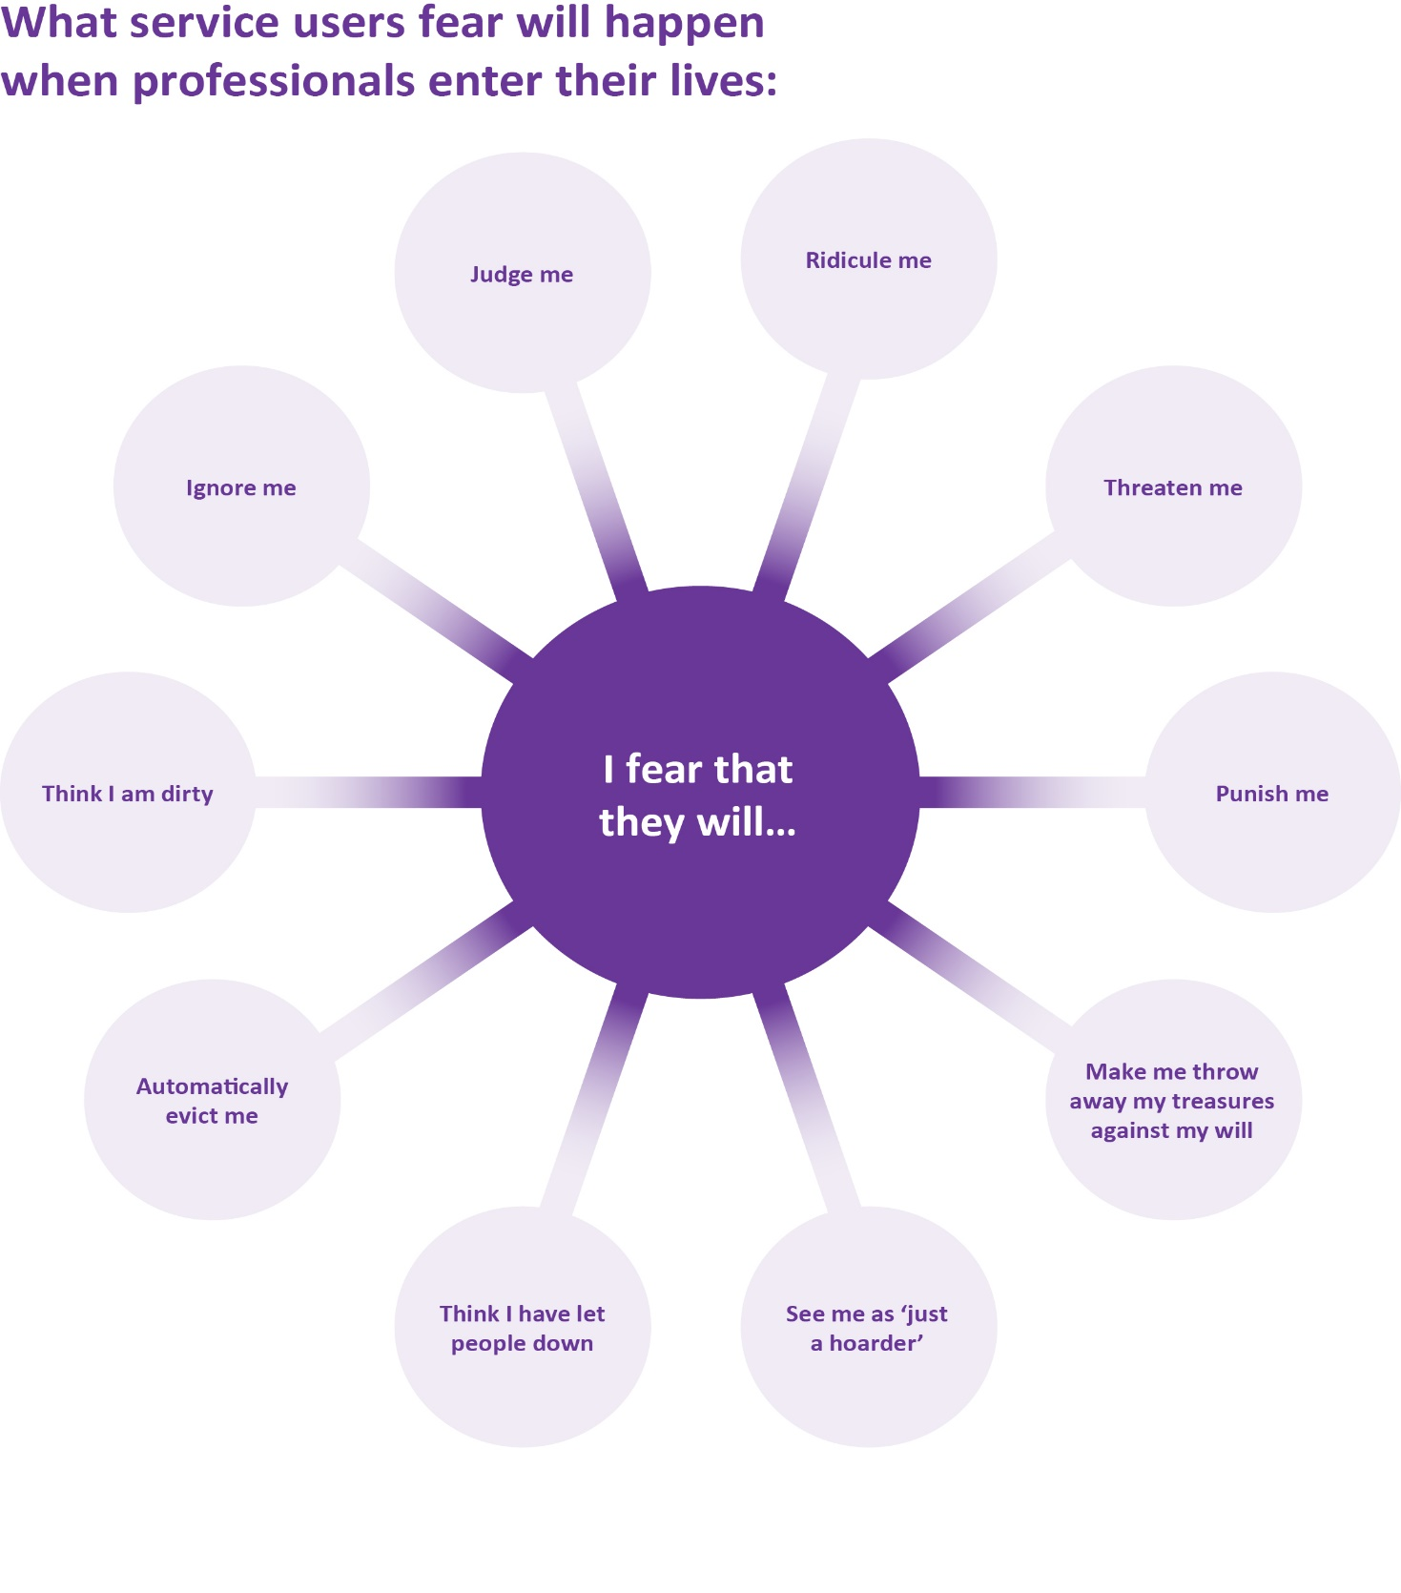

The Mental Capacity Act 2005: 11 pointers from practitioners

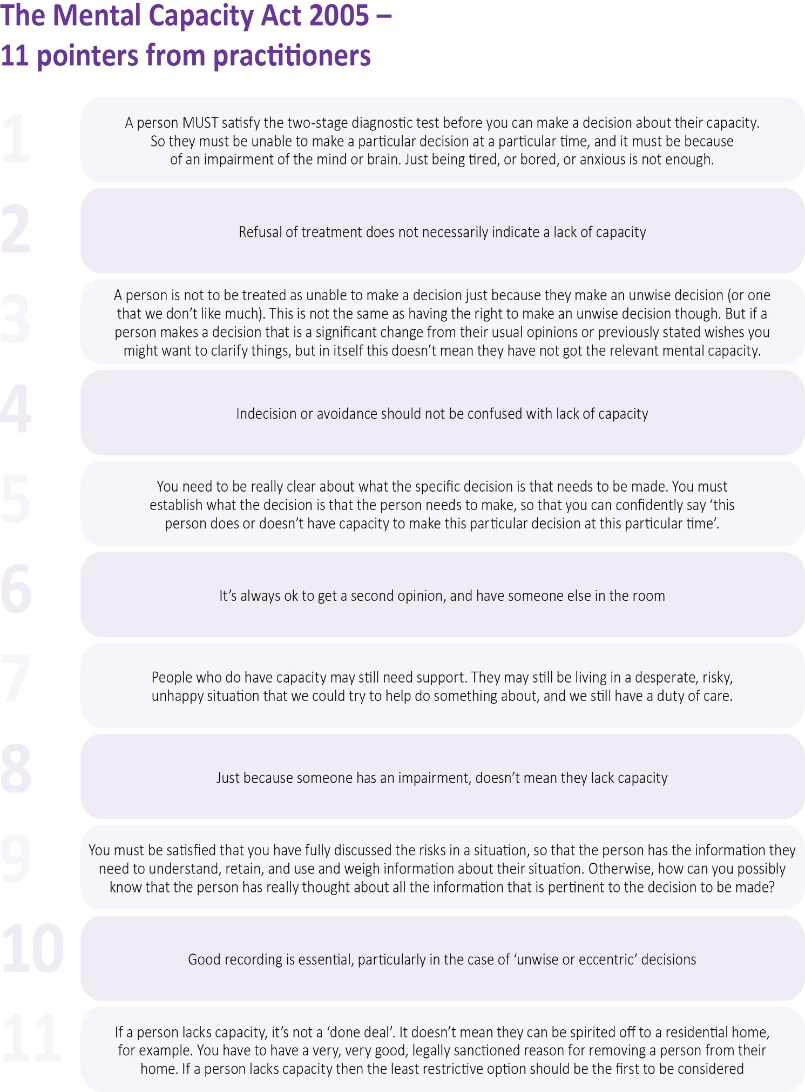

Executive and decisional capacity – exploring this further with people who self-neglect

Mental capacity involves not only the ability to understand the consequences of a decision, (decisional capacity), but also the ability to execute, or carry out, the decision, (executive capacity).
A simple way to demonstrate this is to use ‘tell me/show me’ approaches. Ask the person to ‘tell you’ how they do something, and then ask them to ‘show you’ how they do it.

Suggestions from practitioners about how this could be done

- You need to observe the person’s practical ability to complete actions relating to a decision such as cleaning, shopping or cooking. For example, a person may say they are able to make meals, no problem, but you can’t see any evidence that meals are being prepared or cooking done. You could ask them to show you how they make a cup of tea, or a slice of toast.

- Sometimes, people have physical difficulties with completing an action. For example, a person may say they are able to take their medication independently. But when you look at the medication blister pack it is unopened. It may simply be that the person is unable to open the blister pack unassisted.

- A person may have the ability to self-medicate, but make the decision not to take the necessary medication as they fear the side effects (such as frequent urination), or they lack confidence in its efficacy.

- It may be hard to separate out embarrassment, avoidance, or the person just changing their mind from ‘decisional incapacity’ as they can be almost identical in how they present. People who self-neglect may have compounding factors.

- In hoarding situations, a person may have the ability to clean up or order a skip, but that doesn’t take into account the related emotions – the value of their possessions to them, emotional significance of the items, safety, anxiety or guilt.

- Decisional and executive capacity may be difficult to test in some environments, where a person is less comfortable, such as hospital, and takes time to do. ‘Testing’ decisional capacity may require there to be a level of trust that comes from a more established relationship

‘Have you tried?’
The first thing any professional involved has to do is to get over the person’s doorstep – and this can be extremely hard to do, whatever the presenting issue is. In this scenario, neighbours have raised concerns about Mr W – but he won’t let anybody in.

Before you go out, think about:
- Are you the ‘preferred professional’ for Mr W? If not, who is?
- Do you actually need to get over the doorstep at this point? Is it necessary to meet at home? Where else does Mr W go? Can you meet him outside his home in a neutral non-threatening place – Café? Pub?
- Would Mr W like to bring a friend or have a friend present when you visit?
- Can a family member or neighbour introduce you?
- Can you make an appointment, by phone or letter, rather than just turning up?
- Can you build rapport before the visit on the phone?
- Can you text MR W directly in advance of your visit to re-assure them?
- Agree a ‘secret knock’ with Mr W if he is concerned about letting people in
- Be discrete, because Mr W won’t want to lose face with his neighbours
- Try joint visits with referrer or someone Mr W trusts. Think about what other services are likely to have contact with him, such as the Fire service, Housing, utility companies.
- Can you enlist the help of faith, voluntary and support services, Church leaders and so on.
- If Mr W is known to your service, use your previous experience. What has worked (or failed) before?

When you go out:
- Plan what you are going to say ahead of time
- Don’t wear a uniform if at all possible
- Don’t go ‘suited and booted’, in masks, PPE etc if this is possible (but it may be mandatory for you, particularly with Covid)
- Consider what can be offered to make things better
- Be open and honest about why you are there.
- Be informal
- Getting in does not necessarily mean getting on - engage, engage, engage
- Do not be oppressive and forceful
- Are there little opportunist things you can make the most of? Offer to buy milk!
- Approach from a positive not a critical angle
- Be conscious of your body language and compromise yourself sometimes, so you don’t make people feel uncomfortable, so sit down if Mr W offers you a seat, even if the chair looks grubby.

If you fail to get in:
- Revisit all of the points above
- Be persistent
- Try cold calling
- Put a note through the letterbox, giving Mr W another time when you will call back
- Put a note through the letterbox asking Mr W to phone you
- Use predictable crisis events to get in
- Contact police if Mr W has not been seen for some time, or if there are any concerns. If it is a non-emergency, phone 101.

Have you tried? (continued)

Finally, Mr W has let you in, but is very uncommunicative and suspicious

Introduction:
- The first 5 minutes is very important!
- Ask Mr W to show you how he does things around the house
- Start with safe conversations using visual clues– look at family photos, ask about hobbies, what are you having for tea, etc
- Try to not show your opinions or be judgemental
- Look for positive avenues and topics of conversation and developing them
- Try to find a common interest – the football, the weather
- Don’t try to get things done, do nothing, just chat …can be very different from normal visits
- Don’t make promises you can’t keep, be honest, right from the start

When you are doing your assessment:
- Focus on identifying a health/care need and possible solutions which Mr W is agreeable to
- Ask if you can contact family/carers. Only do so with Mr W’s permission.
- Check entitlements and other services/agencies available
- Offer good choices.
- Create outcome focussed assessments with Mr W
- Set realistic SMART goals (specific-measurable- attainable-relevant- time-bound)
- Focus on risks rather than telling Mr W how to live
- Think about the consequences of risks and be honest
- Make sure the action plan and reviews are created by Mr W
- Work with Mr W, don’t do it to him
- Try a staged approach, not doing everything at once
- Celebrate successes
- Think about your verbal and non-verbal approach, be an active listener

Practical support:
- Offer support on a trial basis
- Consider any other sources of help such as family members
- Are there any immediate agreed actions (quick wins?)
- Work with Mr W to establish his priorities in terms of needs
- Always try to have another option
- It’s okay to dangle carrots when you’ve considered different approaches.
- Educate … health, safety, support
- Emphasise the positives
- For social workers: Persuade managers to waive or be flexible about Mr W’s financial contributions, if this appears to be the main obstacle to ongoing intervention
- Looking for support groups and peer support
- Think about what other professionals or services you could involve
- Is there a role for a social prescribing link worker? More information here: https://www.england.nhs.uk/personalisedcare/social-prescribing/

Part 2: Working with self-neglect: supporting people towards self-care

Imagine how unpleasant and embarrassing and shameful it must be to know that your breath smells, and your teeth are badly decayed. That you smell of urine or faeces or sweat. That your nails are black with dirt. That your toenails are curling under your toes because they are so long that you can only hobble about. Imagine if you are afraid to look in the mirror because you know your hair is dirty, unbrushed, matted, uncut. Imagine if you are a man who used to think he looked quite nice clean shaven, who hasn’t had a shave for years, and knows he looks a state. Imagine if you were a woman who used to like to look neat and tidy, and now you can see the stains on your clothes, the food spills down the front of your dress, the dirt around the cuffs and the neckline. Imagine how embarrassed, how ashamed, how hopeless you would feel. Then imagine letting anyone into your home to see you looking like that.

Practitioners working with some service user groups felt that often the people they worked with had such low self-esteem that they believed that self-care just wasn’t worth it, or that they didn’t deserve to look or feel good about themselves. There are important things to remember.

Targeting efforts
Here, we think about targeting specific care tasks, rather than trying to sort out the whole thing at once, which can be overwhelming for the person, frustrating for the worker, and lead to the person disengaging.
Thinking about targeting a specific care task, it’s not hard to see that many are actually quite complicated to carry out successfully – it takes everyone some years to learn to be fully self-caring. Therefore, it’s super important to be really thorough about why a person is neglecting a particular care task, and whether we are giving them every chance to demonstrate that they can do it, before we jump to thinking about whether they do or do not have the capacity to decide to do it. How many of us would really make a decision to be unclean, unkempt, uncomfortable?

Utilities
Doing many of these care tasks relies on utilities that most of us take for granted – running hot and cold water, heating and lighting. Some people who self-neglect also experience domestic neglect or live in squalor, part of which is that they don’t have these things, for whatever reason. We’ll look at utilities in the section ‘Maslow House’, but it’s really important to consider whether people have the utilities needed to carry out the care tasks listed here. In particular you need to explore whether the person does have an electricity and gas supply, but can’t afford to switch them on, or is afraid to do so because of the bills, or are in fuel debt, or has no credit left on their gas card or electricity key. This is particularly acute as we go into the Winter of 2022.
Where people are in electricity or gas debt, the person (or you, if it would be seen a part of your job) can contact the energy supplier to discuss options to clear any outstanding debts, reduce any debt repayments or to request an emergency credit. Some electricity and gas suppliers have Trusts or Funds which can offer grants to their own customers who are in debt. You could also try:
https://www.glasspool.org.uk/ - provides grants support for people experiencing financial hardship, that has no restrictions on who they can help. They provide timely, small, one-off grants to individuals, couples and families for everyday items.
https://www.smitfc.org/the-vicars-relief-fund/ - provides small-sum, rapid response grants to prevent eviction or access accommodation for people who are homeless or vulnerably housed.
https://www.knowsley.gov.uk/residents/benefits-and-grants/emergency-support-scheme - Knowsley’s Emergency Support Scheme can provide help to Knowsley residents with food and/or fuel (not cash) in an emergency that is unforeseen, could not have been avoided, or poses a potential risk to the health and safety of the person or their family.

Further information:
https://www.ageuk.org.uk/globalassets/age-uk/documents/factsheets/fs1_help_with_heating_costs_fcs.pdf
https://www.carersuk.org/help-and-advice/financial-support/help-with-household-finances/fuel-costs

How to proceed
When we’re getting to know the person, and what is important to them, some advice is:
- Find out if the person agrees that this is a problem? Would they like it sorted out?
- Start as small as possible.
- Remember that there is always an option to do nothing. Don’t turn it in to a fight.
- Be clear about what is important to you – depending on your job, you will also have priorities, concerns and responsibilities that cannot be ignored.

Targeting support:

Task – Equipment – Abilities - Expertise – Alternatives

Using this way of targeting a particular self-care task, we can see the different layers that may be involved to achieve the target – the task at the centre – and be clear about what, or who, is needed to do this.

So practitioners, whatever their professional background, can usefully think through:
- What exactly is the self-care task that we are looking at? (being very specific that this is care of the body, personal care, taking place within the person’s home or living space, rather than activities of daily living (ADL) such as shopping or paying bills. Many ADL follow on from self-care, such as needing to shop in order to cook, in order to eat, but the focus here is on direct care of the body.

- Does the person have the equipment necessary to do it? (this can be very simple – a toothbrush, a comb)

- Does the person have the physical and mental ability to do it? Can they use the equipment unaided? Can they sequence the task correctly? Do we know for sure that the person knows how to do this thing?

- Who could help them do it, perhaps either via a specialist assessment, or regular assistance?

- What are the alternatives to doing this particular care task? Is there a temporary fix, or an easier way of doing it?

Practitioners shared their ideas using this framework in relation to self-care and self-neglect. The self-care tasks we looked cover seven areas, but these may vary according to the service user group you work with.

We then broke these down even further to be precise about the task and what or who was needed to achieve it.

Washing the body

Task/problem | Equipment | Abilities | Outside Expertise | Alternatives | Further information
Not washing at all | Bowl, or sink  Soap  Towel  Flannel | Dexterity to hold a flannel and apply it to face and body.  Awareness that it is an appropriate time to wash. | Domiciliary care  Referral to Occupational therapist for washing aids | Domiciliary care to help with a flannel wash/strip wash  Start with a good old ‘lick and a promise’ – just washing hands and face perhaps.  Using sanitiser gel instead of water  Use bottled water if no tap water | https://www.nhs.uk/conditions/social-care-and-support-guide/practical-tips-if-you-care-for-someone/how-to-help-someone-you-care-for-keep-clean/
Not caring for feet (particular issue for homeless people) | Essential: Bowl, soap, towel  Clean socks | Dexterity –to be able to wash feet | Community podiatrist – either domiciliary or at a clinic.  Private podiatrist.  Domiciliary care to assist
Not showering | Useable (accessible &clean) shower  Soap  Towel  Bath mat | Ability to get shower temperature right, and turn it off and on.  Ability to dry self afterwards.  Ability to mobilise in the shower | Domiciliary care  Occupational therapist Disabled Facilities Grant for shower/wet room installation  Shower chair | Strip wash by domiciliary carer  Using other showering facilities, eg the gym  Going to family members house for a shower  Provide privacy gown
Not bathing | Useable (accessible and clean) bath  Soap  Towel | Ability to get bath temperature right, and not overfill it.  Can they get in and out of the bath? | Occupational therapist for bathing assessment- bath seat, grab rails, etc  Domiciliary care to assist | Strip wash by domiciliary carer  Going to family members house for a bath  Provide privacy gown
Not shaving | Bowl or sink  Towel  Razor | Considerable dexterity for a wet shave  Less dexterity for a dry shave | Domiciliary care to help with shave  Occupational therapist for shaving aids | Visit to the barbers | https://focusondisability.co.uk/disability-aids-mobility-equipment/dressing-aids-grooming-aids/

Continence care
Task/problem | Equipment/utilities | Abilities | Outside Expertise | Alternatives | Further information
Involuntary urinary incontinence  (including eneuresis/bed wetting) | Continence pads  Bed or chair protectors  Catheter and supplies  Clinical waste bin  Essential: Hot water  Useful: Shower or bath to get cleaned up | Dexterity – adjusting underclothes, wiping themselves.  Mobility – are they able to get to the toilet in time? Can they sit and the toilet and stand up afterwards?  May not be able to change them themselves. | Continence nurse or continence physiotherapist  Domiciliary carer to help change pads  Medication review with pharmacist– eg are water tablets adding to the problem? | Buying own incontinence pads | https://bladderhealthuk.org/  https://www.ageuk.org.uk/globalassets/age-uk/documents/information-guides/ageukig15_bladder_bowel.inf.pdf
Involuntary bowel incontinence | Continence pads  Bed or chair protectors  Essential: Hot water  Useful: Shower or bath to get cleaned up | Dexterity – adjusting underclothes, wiping themselves.  Mobility – are they able to get to the toilet in time? Can they sit and the toilet and stand up afterwards? | Domiciliary carer to help change pads  Continence physiotherapist or continence nurse to advise on dietary changes  bowel training, pelvic floor exercises  Medication review  Referral to GP for investigation of underlying health causes | Buying own incontinence pads | https://bladderhealthuk.org/  https://www.ageuk.org.uk/globalassets/age-uk/documents/information-guides/ageukig15_bladder_bowel.inf.pdf
Voluntary urinary incontinence and/or faecal incontinence  (does the person appear to be neglecting to take action to avoid wetting or soiling, or are they simply forgetting to go to the toilet?) | Toilet paper, toilet cleaner  Clean underwear  Bed or chair protectors  Essential: A working toilet  A shower or bath to get cleaned up | Dexterity – adjusting underclothes, wiping themselves.  Mobility – are they able to get to the toilet in time? Can they sit and the toilet and stand up afterwards?  Is the toilet easily accessible? If it is upstairs, can the person actually get upstairs? | Continence nurse or continence physiotherapist  OT or community nurse to see if toilet frame, raised toilet seat, commode, or grab rails would help  GP to check if an underlying medical problem, eg early dementia  Referral to mental health services if it seems to be deliberate urination or defecation with smearing. | Going to the launderette  Paying for a laundry service  Assistance from family with laundry  Using a urine bottle (men)

Dental care

Task/problem | Equipment & Utilities | Abilities | Outside Expertise | Alternatives | Further information
Caring for teeth and gums | Toothbrush  Toothpaste  Essential: somewhere to spit – sink or container  Useful: Running water, but can be done with bottled water | Manual dexterity: to hold the brush, put the paste on the brush.  Mobility: able to move wrist and arm. | Community dentist to check if there is tooth decay which is causing pain and making the person reluctant to clean teeth.  Special Care Dentist for people with disabilities  OT or dentist to assess for aids, eg wide handle large toothbrush, handle grippers. | Chewable disposable tooth cleaning, eg Fuzzy Brushes, dental capsules  Mouth wash | https://www.electricteeth.com/uk/dental-care-disabilities/  https://www.bsdh.org/index.php/how-to-find-a-special-care-dentist  https://www.dentalhealth.org/dentalhelpline
Caring for dentures | Dentures  Container  Denture brush & cleaner  Denture Grip  Mouthwash  Useful: Running water, but can be done with bottled water | Manual dexterity: ability to put teeth in and out  Ability to remember to take them out at night | Community dentist to check denture care. | Permanent dentures or implants.  Don’t try to wear the dentures – some people choose not to.  But – this may mean they choose softer foods, which may lead to a nutritionally poor diet. | See links above

Hair and nail care

Task/problem | Equipment/Utilities | Abilities | Outside Expertise | Alternatives | Further information
Not cutting fingernails or toenails | Essential:  Nail clippers or scissors  Useful to have as well:  Nail file  Bin for the clippings  Useful, but could do it without: Lighting and water | Dexterity – to work the clippers or scissors. Must be able to hold the tool comfortably.  Mobility/flexibility if toenails are to be cut.  Good enough eyesight to cut accurately  Good enough eyesight to cut accurately | Asking a family member to do it  Mobile manicurist  Community podiatrist – either domiciliary or at a clinic. | Go for a manicure or a pedicure  Ask a family member to do it (not if the person is diabetic though)
Not washing hair | Shampoo  Towel  Sink or bowl  Essential utility: hot water | Ability to raise arms above head, to wet and rinse hair, dexterity to rub in shampoo, ability to measure out a portion of shampoo | Domiciliary Care to assist  Occupational therapist for aids | Dry shampoo  Individual sachets of shampoo  Mobile hairdresser to come to the house  Going to family member’s house for a hair wash  Going to the hairdressers | https://focusondisability.co.uk/disability-aids-mobility-equipment/dressing-aids-grooming-aids/
Not brushing or cutting hair | Brush/comb  Essential utility: Lighting to see what you’re doing | Ability to raise arms to head, to hold a brush or comb | Domiciliary care to assist  Occupational therapist for aids | Mobile hairdresser to come to the house  Going to the hairdressers | https://focusondisability.co.uk/disability-aids-mobility-equipment/dressing-aids-grooming-aids/

Dressing

Task/problem | Equipment/Utilities | Abilities | Outside Expertise | Alternatives | Further information
Not changing clothes or wearing clothes appropriate to the season or temperature. | Clean clothes to change in to | Dexterity – can the person undo buttons and zips, pull clothes off over their head, take off and put on socks, tights or trousers, etc.  Good enough eyesight to see if their clothes are stained and dirty, done up properly, etc.  Knowledge about how often to change clothes, particularly according to seasons and temperature. | Domiciliary care to help change clothes regularly, and to encourage this  Occupational therapist – to do a dressing assessment and provide any aids, such as sock pullers on. | If the person is very short of clothes – ask around the office for donations  Go charity shop shopping. | Knowsley Household Support fund may help with some essentials (depending on where the person lives)  https://www.knowsley.gov.uk/residents/benefits-and-grants/household-support-fund  Turn2Us may have suggestions https://www.turn2us.org.uk

Eating

Task/problem | Equipment & Utilities | Abilities | Outside Expertise | Alternatives | Further information
Eating- malnutrition or over-eating  Eating and cooking shouldn’t be rolled in to one – each should be considered separately.  Eating is a self-care task, and neglecting to eat, or over-eating, can have very serious consequences.  Cooking is an activity of daily living – if you can’t cook, you can still get by. | Teeth  Food  Useful:  Plate, cup and utensils (but could be disposable)  Electricity or gas to heat food and water (but not essential if cold food and drinks)  Fridge to store perishable food  Waste bin  Useful if cooking is being done:  Working stove or microwave  Saucepans  Smoke alarm  Fire blanket | Able to chew and swallow safely and without pain  Dexterity to manipulate cutlery  Do they understand the effect of not eating or eating a very poor diet?  Do they understand the importance of a balanced diet, or following a particular diet for a particular medical condition (eg diabetes)  This may also lead to consideration of the person’s ability to cook - can they move around the kitchen, can they stand, can they see what they are doing, can they set a microwave?  Do they have cookery skills? Can they follow packet instructions, get timings right.  Dexterity – can they remove lids, open tins, peel, chop etc | Dietician  Dentist  Dom care to provide meals and encourage eating and drinking  SALT swallowing assessment  OT for provision of adapted cutlery.  Diabetes nurse  Mobile meals  Occupational therapy – kitchen assessment, provision of aids such as tap turners, kettle tippers etc.  Supermarket delivery  Having meals delivered – eg Wiltshire Farm Foods  https://www.wiltshirefarmfoods.com/  Buying pre-packed meals | If they are not eating for medical reasons:  Meal replacements – eg Ensure (via dietician  Food supplements (via dietician)  If they are not eating properly because they don’t have any food:  Food bank  If they are not motivated to eat or prepare food:  Going out for meals – day centre? Café? Voluntary provision?  Consider Lunch clubs in the local area, eg  https://www.thelivewelldirectory.com/Services/3693/St-Gabriel-s-Luncheon | Access to Knowsley Foodbank / Knowsley Food Support  There are 2 ways to access food from a Knowsley Foodbank site, either through a voucher or via a telephone assessment  through Knowsley Food Support 0151 538 8243.  Food is also available through community groups across the borough. The locations of the organisations and the support they offer with food and essentials is listed on the council website

Drinking

Task/problem | Equipment & Utilities |  | Abilities | Outside Expertise |  | Alternatives | Further information
Not drinking/ staying hydrated or excessive drinking |  | Liquids  Cups and glasses  Useful: cold running water &  Fridge  Kettle | Mobility – is the person not drinking because they can’t get to the toilet very easily? Or is excessive drinking contributing to incontinence? |  | Speech and language therapy swallowing assessment  Dietician to look at what is being drunk, e.g., high caffeine intake, or excess fizzy drinks.  Occupational therapist for provision of adapted cutlery.  Community pharmacy review – medications that are causing a dry mouth or thirst for example. | Bringing in hot drinks from outside  Domiciliary care to leave a flask of hot drink  Go out for hot drinks | https://www.ageuk.org.uk/salford/about-us/improving-nutrition-and-hydration/drinking-well/  https://www.alzheimers.org.uk/get-support/daily-living/drinking-hydration

Healthcare

Task/problem | Equipment | Abilities | Outside Expertise | Alternatives | Further information
Not taking or using medication which is usually self-administered | Tablets, inhalers etc  Pill/ Dosette box  Water or food to take meds with  Useful: Identified place to keep medications  Lighting to see tiny pills | Dexterity to open blister packs  Organisational ability to remember to take meds at a particular time and to read and follow directions of meds  Eyesight to see tiny pills! | Community pharmacist to provide blister packs and help the person understand what the meds are for.  Family putting meds in Dosette box  Reminder/alerts – phone?  Online prescription ordering | Domiciliary care to prompt with medication  Pharmacist to deliver  Community nurse to check meds | https://www.nhs.uk/conditions/social-care-and-support-guide/practical-tips-if-you-care-for-someone/medicines-tips-for-carers/

Health care and mental capacity
There is sometimes a distinction to be made between people who are neglecting themselves by not taking medications because they don’t have the abilities needed, and people who are refusing to take medication or accept medical treatment in the home. Sometimes people’s reasons for not taking medication are quite logical, even if not a good idea – not taking water tablets because it’s too difficult to get up to go to the toilet frequently for example.
In situations where a person is self-neglecting by not taking medication, the person’s mental capacity would need to be assessed, to decide whether they had the capacity to make the choice to refuse these treatments, with clarity needed around whether they could use and weigh all the information about what the effects would be of them having or not having the treatment. You’d want to know that they really understood that the refusal could seriously harm them.
Most medications would usually be expected to be self-administered (the rest of us would manage these for ourselves). But of course, there are medications and treatments which community nurses would usually be responsible for (changing dressings, or injections for example). They may also be faced with people who refuse treatment.
A capacity assessment with a finding of lack of capacity will not ‘solve’ such situations though. Even if the conclusion was reached that the patient did not have the capacity to refuse the treatment, the problem then still arises of how exactly you are going to administer the unwanted treatment. When someone is their own home, in reality it will be very difficult to force them to have a treatment they don’t want, even if on paper they lack the capacity to decide. This is where practitioner skills of listening patiently, explaining clearly, finding all the possible ways of giving the person good information about the treatment they are refusing, and gently trying to persuade, all come in to play. This kind of decision will need to be re-visited frequently, particularly if the patient is going to deteriorate without the treatment. It’s also an important area to think about who does the patient know and trust, and respect the opinion of, such as their GP or a family member.

Odour
There is one important thing that probably cannot be resolved by simply addressing one single self-care issue, and that is odour and smell. We don’t like to talk about it, but for many people who self-neglect, unpleasant body odour will be an obvious, extremely stigmatising, and sometimes overwhelming problem. It’s really difficult to talk about without offending the person, and in most cases, it would be inappropriate and shaming to focus on it alone. However, ultimately it will lead to social exclusion and isolation for the person, so it’s important not to ignore it. For more on this, there is a very interesting discussion here, with many really useful suggestions: https://peterbates.org.uk/wp-content/uploads/2017/04/vilebodies_-_most_recent.pdf
Many of the things that are suggested above contribute to body odour – being unwashed, not changing or washing clothes, becoming incontinent. Thus, dealing with these issues will hopefully begin to deal with the issue of body odour and smell. When we discussed this issue in writing the guide, practitioners talked about the importance of positive reinforcement and encouragement and the centrality of trying to help the person feel better about themselves.
There are a couple of other considerations though. Firstly, is the body odour a recent thing, and could it be in any way related to the loss of sense of smell following Covid (known as anosmia)? Losing the sense of smell puts people at risk because they can’t smell, for example, smoke, or decayed food. So that may need to be checked out.
Secondly, there may be medical reasons why a person has body odour (such as a fungal infection), or suffers excessive sweating, or hyperhidrosis. Many drugs can have secondary hyperhidrosis as a possible side effect. A referral to the GP, or a medication review might be appropriate to eliminate potential causes.

How to fund these suggestions

Many of the areas of care on the charts above will have some financial cost, which of course raises the question of how to pay for things.
Firstly, many of the areas of care on the grid are directly listed in the Care Act eligibility criteria – for example, being appropriately clothed, managing toileting needs. So, following a Care Act assessment, the person may be eligible for a care and support package, or a direct payment.
There is support available from the Department of Work and Pensions. For example, budgeting loans are available to help pay for essential items, for people on certain benefits. More information here: https://www.gov.uk/budgeting-help-benefits/eligibility
Knowsley Council Emergency Support Scheme may provide some support for essential items of furniture and/or white goods in very specific circumstances where the resident has suffered a major upheaval such as being homeless or fleeing domestic abuse, or where they are at risk of going into institutional care. More information here: https://www.knowsley.gov.uk/residents/benefits-and-grants/emergency-support-scheme

Charitable organisations, locally and nationally, may be able to offer financial or other support
Live Well is a directory of care and support services, activities and information covering Knowsley and Liverpool. Click here: https://www.thelivewelldirectory.com/
Turn2Us is a national organisation that helps people in financial need with charitable grants and other financial help. Click here: https://www.turn2us.org.uk/About-Us/Our-Campaigns/Living-Without-Campaign/Where-to-get-help
Depher (Disability and Elderly Plumbing and Heating Emergency Repair) is a national organisation which provides help to people who can’t afford repairs to their heating or plumbing in an emergency. It also provides small cash grants. Click here: https://www.depher.com/
The Vicar’s Relief Fund (VRF) helps those who are homeless or vulnerably housed through small-sum, rapid response grants to prevent eviction or to access accommodation. Frontline workers can apply on behalf of their clients for grants to help prevent eviction (of up to £350) or access accommodation (of up to £500). Click here: https://smitf.flexigrant.com/

Part 3: Hoarding

Getting rid of stuff can be very difficult to do.
But why do we hold on to stuff that other people might think was rubbish? Practitioners confessed:
- I love it
- It has sentimental value
- It’s connected with happy memories
- It might be worth something or be collectable
- I paid good money for it
- I might need it, or it may come in handy one day!
- I want to pass it on to my children
- I might fit into it one day, if the diet works
- I want to add it to my collection
- It gives me feelings of comfort
- It gives me feelings of safety and security
- I don’t like waste
- I think it brings me luck; I’d feel a bit superstitious about getting rid of it
- I’m paranoid about losing it
- I’m a bit compulsive about these things
- Keeping things is just a human quality – a need or a want that we all have
- I might not be able to afford another one in the future
- Things I’m attached to give me comfort when I’m lonely.
- I can re-live experiences and emotions through the object.
- It’s what I grew up with– parents kept stuff. Even if your parents didn’t, either way has an impact
- It means everything to me – I have never had it before.
- I don’t know, I just do.

Think about how this relates to the idea of executive and decisional capacity. A person may have decided that they could do with getting rid of some things. They know that they need to. But when it comes to actually doing the task of getting rid of stuff, or ‘executing’ it, many other factors and feelings, as we can see above, might get in the way.

Do we expect more from service users then we are able to do ourselves?

How do practitioners get rid of stuff themselves?

- Weigh up if it has a use or purpose
- Ask myself ‘when did you last use or wear this?’
- Throw it out, take it to the tip
- Recycle
- Donate to a charity shop
- Sell, e.g., Ebay, car boot sale. Garage sale
- Give away, leave at the end of the path
- Nobody mentioned getting a skip!

What can hinder getting rid of things?

- Having to get into the right mindset, and not having enough time.
- Not trusting the people who think we should get rid of things
- The sheer thought of completing the task
- Embarrassment at how things got into this state

What are our reasons?

Why do we want to help people who hoard get rid of stuff? Are they justifiable reasons?

- Not safe – hazardous
- To prevent vermin and rodents
- Because of the fire risk
- To prevent falls and other injuries, to create a safer space
- To be able to get access to rooms and to be able to use rooms for their purpose
- To increase social interaction and reduce isolation - to be able to welcome people into your home
- To allow for property maintenance
- To help people improve their mental health and make them feel better
- To give them comfort in their homes, make places more homely

Thinking about our reasons for intervening, and listing and prioritising them can be really useful, both for the work that we are doing with people, and for working together with other agencies, who may not always have the same priorities.

How can we help people who hoard get rid of stuff?

Remember that one size doesn’t fit all, and these ideas will have to be tweaked for each individual person.

Practically:
- Break down tasks/areas to sort out
- Address one room at a time
- Try ‘Stay/go/maybe’
- See if items can be recycled, sold, or donated to people who have nothing
- Looking at storage options like hangers and boxes – provide ‘paid for’ storage
- Replace old and broken items with new ones
- Set timescales
- Get family and outside agencies involved
- Find charity funding, e.g., Vicars Relief Fund will give money for a clean up
- Hire a skip – this is a contentious one though. Many practitioners feel that just binning doesn’t work
- Go at the person’s pace when supporting them to move or remove items, otherwise it may feel chaotic to the person.
- If you are going to offer a skip (the dreaded ‘S’ word’), is it because all the items are broken? Can some be recycled instead?
- Just because someone has a lot of items doesn’t mean they are unhygienic
- Small stages and small steps

Emotionally:
- Ask the person how they would like to proceed to give them their power and put them at the centre of the support.
- Talk to the person about the risks and hazards to themself and others
- Find out the reasons as to why hoarding happens, and explore the triggers
- Try to understand why the person hoards
- Try to build a rapport with the person, a trusting relationship
- Listen and empathise
- Recognise it will be a long process
- Agree to break down the task/areas
- Allow the person themselves to guide if they want to
- Find out if the person would consider CBT/psychological therapy
- Will the person agree to a referral to other agencies (but you must be really clear about what they could do)?
- Would the person accept support from others - peer support, online support groups, etc?
- Would a 1:1 or group approach help, depending on the person
- Would the person benefit from having an advocate?
- Both practical and psychological support are needed
- Remember that the meaning attached to items is logical to the individual

The Mental Capacity Act and Hoarding

When thinking about a person’s mental capacity in relation to hoarding, it can be quite difficult to know how to assess whether someone can make decisions about their own items and belongings. A recent case in the Court of Protection, Re: AC & GC (Capacity: Hoarding: Best Interests) gives some useful information for practitioners.
GC lived with his 92-year-old mother, AC, who had dementia, in a property where there had been longstanding problems with hoarding and cleanliness. The court had to decide whether AC should return home from the residential care setting to which she had been temporarily moved. They wanted to know whether GC, who was diagnosed with Asperger’s Syndrome, anxiety, OCD, and hoarding disorder, had capacity to make decisions regarding his items and belongings, and also those of his mother. It was agreed by the court that the information relevant to making decisions about items and belongings fell into 5 areas:
- Volume of belongings and impact on use of rooms: the relative volume of belongings in relation to the degree to which they impair the usual function of the important rooms in the property for you (and other residents in the property), e.g., whether the bedroom is available for sleeping, the kitchen for the preparation of food etc. Rooms used for storage (box rooms) would not be relevant, although may be relevant to issues of (3) and (4).

- Safe access and use: the extent to which you (and other residents in the property) are able or not to safely access and use the living areas.

- Creation of hazards: the extent to which the accumulated belongings create actual or potential hazards in terms of the health and safety of those resident in the property. This would include:
- The impact of the accumulated belongings on the functioning, maintenance, and safety of utilities (heating, lighting, water, washing facilities for both residents and their clothing).

In terms of direct hazards this would include:
- key areas of hygiene (toilets, food storage and preparation),
- the potential for or actual vermin infestation
- risk of fire to the extent that the accumulated possessions would provide fuel for an outbreak of fire, and that escape, and rescue routes were inaccessible or hazardous through accumulated clutter.

- Safety of building: the extent to which accumulated clutter and inaccessibility could compromise the structural integrity and therefore safety of the building.

- Removal/disposal of hazardous levels of belongings: that safe and effective removal and/or disposal of hazardous levels of accumulated possessions is possible and desirable on the basis of a “normal” evaluation of utility.

It is interesting to link these 5 capacity factors, to our justifiable reasons for wanting to help people get rid of stuff (p26). There are a lot of similarities. If you want to read the full judgement, it is available here: https://www.bailii.org/ew/cases/EWCOP/2022/39.html

Part 4: Domestic neglect

Probably by this point the person is going to need some external help on a regular basis, to keep things ticking over. There are many reasons why people might refuse external help, such as not wanting outside interference, being proud of being independent, feeling ashamed of asking for help, or simply not wanting to pay. In this section we consider if there are ways in which we can make external help more acceptable to people, to help them to remain in their own homes and to stop the situation deteriorating further?

Making external help more acceptable

- Listen to the individual and prioritise what is important to them, e.g., getting to the kettle to make a drink, being able to access the fridge, being able to access the toilet
- Let them know what support and services are available in the local area. Take leaflets with you, and use visual prompts
- Focus on the benefits and positives of having support
- Focus on a specific area – let’s get your chair/bed sorted out
- Make them aware/be honest about the risks of not having support
- Do something which is nothing to do with the state of the house, i.e., help resolve the issue of car needing fixing
- Set up a meeting with relevant people on neutral ground. May need to try to form a relationship outside the house
- Reassure people that we will work with them
- How do they want to work with us?
- Build a rapport/ banter/ find a connection, common ground
- Find out their likes and dislikes
- Agree small steps – no grand gestures or plans
- Be clear about potential costs, and support the person with finance/benefits advice
- Be approachable, show professional curiosity
- Use positive reinforcements and compliments – how have you progressed?
- Think about how we present – uniforms sometimes worry people
- Being considerate of their needs
- Valuing the person’s perspective/perception of you
- Talk calmly/actions/body language
- Honesty – don’t promise what you can’t deliver
- Be clear what support is required from them
- Start slowly, don’t overwhelm people
- Does the person want to meet at another venue – ‘Let’s go out for a coffee’?
- Find out what time of day is best for the person to have others in their house
- Start slow, one person, get relationship, then introduce others
- Explain what you are going to do, keep to it, deliver
- What does the person want, or see as the issue, the next steps?
- What’s worked well/not so well previously?
- Don’t give up
- Revisit
- Don’t make or convey judgements

Part 5: Severe domestic squalor: Maslow House

In working with people who self-neglect or hoard, it can be difficult for different practitioners to agree priorities, because different professionals often have different priorities and pressures on them. This can become particularly difficult when working with people who are really struggling, in complex severe domestic squalor situations, where something really needs to be done. So how could we agree a few priorities to help the people we are working with? A report from the Housing Ombudsman in 2021, called ‘Cold Comfort’, says ‘Living in a warm, safe and decent home is a fundamental need and critical to our health and well-being’. This applies just as much to people who live in severe domestic squalor as anyone else.

Perhaps the work of psychologist Abraham Maslow could help. Most practitioners working in health and social care are familiar with Maslow’s Hierarchy of Needs, the pyramid with 5 levels.
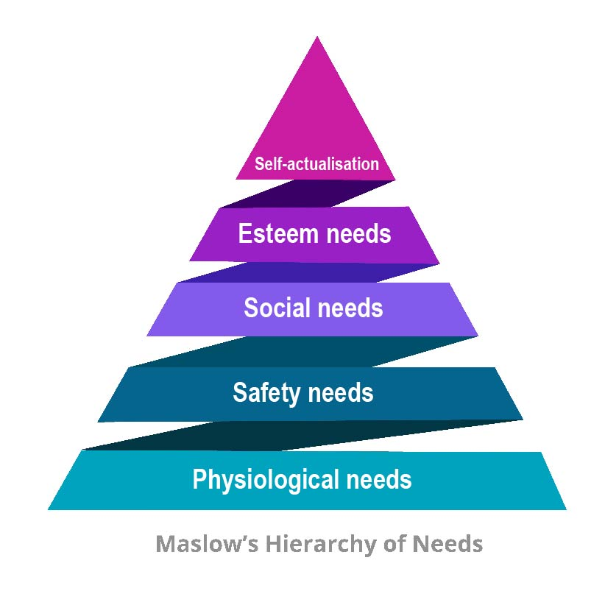

Maslow argued that there were 5 stages of human needs that motivated our behaviour, and that our needs must be satisfied in one stage before we can move on to the next. At the bottom of the pyramid are ‘physiological needs’, the basic needs for bodily functioning (to stay alive). Interestingly, the Care Act eligibility criteria are very much based on these physiological needs. Until we’ve satisfied these physiological or survival needs, we won’t be motivated to work on our safety needs or our social needs, and there’s no way we can ‘self-actualise’ – think about fulfilling our dreams and desires, about directing our own lives.

So, perhaps it would help practitioners working together with people living in extreme squalor, to focus first on the physiological needs that person has – their needs for breathing, food, water, sleep, excretion, warmth, clothing, shelter and making sure these needs are met.

You will have other ideas, depending on the service users or patients that you work with, but some of these suggestions might be useful in helping everyone decide on where the focus should be, and to make sure everyone is pulling in the same direction.

First things first: Focusing on physiological needs

Physiological need | Questions to ask about that need
Shelter | What shelter does the person have? Living on the street? Sofa surfing? Hostel? Shared accommodation? Do they have a safe space?  What are the housing options/solutions depending on needs and risk levels, for them  Property pool – need to match property to need size, so they don’t incur Bedroom Tax  Don’t set them up to fail -will they get in arrears?  Citizens Advice Bureau for advice on finances  Consider the state of the property  Ensure property is safe and secure – is it in disrepair? Is it watertight?  Is the Registered Social Landlord or private landlord involved?
Water | Without water they cannot drink, wash or clean. Why do they have no water?  Is the water turned on? Can they pay the bills?  Do they know how to turn the water on and off?  Have they got leaks or flooding – call a plumber? Contact the landlord?  Do they have access to the rooms where the water is – kitchen and bathroom?  Does everything work?  Are they drinking enough or are they dehydrated?  See the section on eating and drinking in Self-Care section for ideas
Air & Breathing | Can you do ventilation checks?  Is there clean, fresh air?  Do the windows open? Do they have locks?  Is there damp or mould? Can you get a grant for a dehumidifier?  Medical checks - do they have medication or inhalers? Can they use them safely?  Are they a smoker? Do they want to stop? Refer to Cessation Services?  Are there smoke alarms?
Sleep | What might be stopping them sleeping?  Do they have a room to sleep in?  Do they have a bed and bedding? Curtains? Security whilst they sleep?  Are things interfering with their sleep – Anxiety? Meds? Alcohol? Drugs?
Excretion | Do they have accessible facilities – can they get to the toilet?  Do they need continence products?  Refer to continence team, OT, Community Nursing for skin integrity  See sections on toileting needs in Self-Care section for ideas
Food | We need food to survive – we need a nutritious diet.  Have they got access to a kitchen?  Safe food storage – working fridge? Other appliances?  Can the person access to the community to shop?  Can they afford the gas/electricity to cook?  Are they able to cook safely?  Do they have addictions which mean buying food is a low priority?  Do they have food intolerances or special diet requirements?  See sectiosn on eating and drinking in Self-Care section
Warmth | Do they have blankets, bedding, appropriate clothes?  Is the heating working? If not, is there alternative heating?  Can they afford to have the heating on?  Is the gas capped? Is it a private landlord or RSL?  See information in Self-Care about help with heating costs and clothing
If you want to read more, the reference to the ‘Cold Comfort’ report is here:
https://www.housing-ombudsman.org.uk/wp-content/uploads/2021/02/Spotlight-on-heating-and-hot-water-report-final.pdf

Best practice with people who don’t want to engage with services
This section is written mainly for social workers, but hopefully it will also be of general interest to other practitioners.
Find out if the person has care and support needs and offer assessment, and if eligible, provide care and support services. If the person does not want to engage with services or support, it is important to try to talk to the person about why they don’t want to, and whether there are alternative options that would be more acceptable to them. If they refuse to engage, then;

Complete a mental capacity assessment if you can, to explore the decision to refuse services or support which should be time and decision specific. If the adult refuses to engage, gather as much information as possible to inform decision- making, and then;

Complete a risk assessment, ideally with the adult if you can. If the adult refuses to engage, gather as much information as possible to inform the assessment and decision making, then;

Consider whether there is any legal basis to intervene further. At this point you may need to seek advice. It may be reasonable not to intervene further, if no-one else is at risk, and the person’s 'vital interests' are not compromised (immediate risk of death or serious harm, whether a crime has been committed, evidence of coercion). There need to be clear, documented attempts to discuss this with the person to make sure that all decisions are fully explained and recorded, and that they are supported to:
- Weigh up the risks and benefits of different options
- Be aware of the level of risk and possible outcomes
- Agree on the level of risk they are taking (including their capacity to take that risk)
- Offer advocacy or other appropriate support
If the adult continues to refuse to engage, and there are still worries, then;

Record your reasons for not intervening or sharing information, including every detail of your assessment of the person’s capacity and of your conversations with them about the potential risks posed by their action.
Communicate (ideally in writing if appropriate) with the person, making sure that they understand where they can go if they want to seek help in the future. Review the situation regularly, and;

Make sure that other agencies have been informed and involved as necessary. This means that after all reasonable and proportionate attempts to engage are exhausted, and other agencies who may be involved with the person, such as their GP practice, have been informed, the case may then be closed to Social Services.
Where there are no other agencies involved at the point of case closure, and the adult will be without any contact, it may be appropriate to discuss with senior management and consider regular contact with the individual via professional support, review or a care and support package. The frequency and duration should be proportionate to the known presenting risks.

When to keep the person’s case open

Working with people who self-neglect, and building up a trusting relationship with them, can be a very slow, painstaking process. Consistency in terms of the worker who is involved and their approach to the adult is also very important. Practitioners taking part in our self-neglect workshops have told us that this sometimes doesn’t sit well with timescales for closing cases and ending involvement.
However, other agencies, such as GP practices cannot ‘close the case’ and walk away as the person will still need proactive medical care – so it’s really important to be mindful of that, and to make sure that everyone working with the person is aware that a case may be closed to some agencies. Good practice is to make sure that a multi-disciplinary meeting is held before a high risk case is closed, just so that everyone involved knows that one or more agencies may be stepping back.
For social workers especially, there can be pressure to close self-neglect cases, particularly if a service user is refusing to engage, and is deemed to have mental capacity. Yet often substantial worries remain about the self-neglecting person.
Knowsley Safeguarding Adult Board partner authorities have therefore agreed that in particular high-risk, complex self-neglect cases, involvement should continue, and cases remain open.
It is anticipated that the decision to keep a case open longer term than usual, will only apply to a small number of situations, and these will need to be monitored to make sure there are clear aims to continued involvement, rather than the case simply ‘drifting’ along.
It is very important to think about who the best person is to maintain direct involvement over a period of time, as this may not necessarily be a social worker. It may be a community mental health nurse, a tenancy support worker from Housing, or an occupational therapist for example.
The following ideas will, we hope, help all partner agencies to make decisions about keeping cases open in the longer term.

Points to consider when deciding whether to keep a complex self-neglect case open to a worker
Every circumstance where a person self-neglects is unique, so there is not a formula in order to arrive at the ‘right answer’. However, we think that there are eight key areas to consider (see the next two pages).
We hope the ideas which follow will be a useful tool to use in supervision discussions for example and in assessments of when a case should remain open.

How to decide whether to keep a complex case open
In making the decision for a case to remain open and active, you should consider:

- The quality of information as to the circumstances
- The adult’s story and history – what have been major events in their lives, how have they been shaped by these and coped with them, what is important to them?
- Reliability and availability of information
- Existence of care and support needs
- Any changes to presentation, behaviour, or routine
- The presence or absence of coercion
- Any previous family, community, housing or safeguarding concerns
- Awareness of the strength, availability, and responsiveness of the adult’s personal and local networks

- The risks to the person, and to others
- Seriousness of the circumstances
- Risk of death or major harm
- The nature and timing of the risk
- Has it changed over time?
- Does the risk affect others, such as neighbours or other tenants?
- Are there any children involved?
- Has a crime been committed against the person?
- Consider your ‘proportionality and perspective’ about the circumstances.

- The likelihood of the risk actually happening
- Immediate nature of the risk?
- Are all variables being properly weighed?
- Is there any objective or research evidence available?
- Consider the over-influence of the ‘protection imperative’ – ‘What good is it making someone safer if it merely makes them miserable’ (Munby, LJ, In the matter of MM, 2007)
- Are you over-exaggerating the risk? Over-egging the pudding?

- The relevance of the Mental Capacity Act
- Consider mental capacity to decide to do what, and when? Assessments must be issue and time specific
- If you are considering actions that could have a significant impact on the person, you need to be clear that it is the least restrictive option and necessary and proportionate to the presenting risk
- Have all practicable steps been taken to allow the adult to make the decision?
- Making what seems an unwise decision is not the same as being unable to decide
- ‘Lacking insight’ could simply be taking a ‘different view’ to that of professionals
- Have you thought about functional and executive capacity (tell me/show me)?
- Even if the person does not have the relevant mental capacity, their wishes and feelings should be considered, and they must carry weight in your decision making

- The efforts that have been made to engage with the self-neglecting person
- Intervening successfully depends on taking time to gain the person's trust and build a relationship, and going at the person’s own pace. Have you done that? What evidence have you got that you are progressing?
- Use the relationship you have with the person to encourage them
- Encouraging them to continue the conversation with other people who they trust
- Record your reasons for not intervening
- Include detail of your assessment of capacity and of your conversations about the potential risks posed by their chosen action
- All decisions should be fully explained and recorded
- Other agencies should be informed and involved as necessary
- Support the adult to weigh up the risks and benefits of different options
- Review the situation regularly and agree your approach with your manager
- Test out if the adult understands where they can go if they want to seek help in the future

- The strength of the person’s views
- What is the adult’s rationale for their views or opinions?
- Is it consistently stated, or has it changed or developed over time?
- Is what they want to happen possible, lawful and does it impact on other people’s rights?
- Is it legitimate or reasonable in the circumstances?
- Are they declining all support to help address needs, or just some?
- Can they demonstrate an ability to adapt to other changes in circumstances?
- The adult’s rights to privacy and family life could outweigh concerns. You must consider the Human Rights Act.
- Different people give different weight to different factors or concerns – the person may simply not see the situation as being as serious as you do.

- The steps necessary to reduce risk
- Would the steps taken to reduce the risk be lawful, necessary, and proportionate to the risk?
- Consider the important balance between the adult’s rights to life, freedom from inhuman treatment and from discrimination, with their rights to liberty, fairness, and privacy
- Is the intervention proportionate to the need to protect from harm or the real possibility of future harm? If not, then without due care our efforts to safeguard a person may in themselves become abusive
- In most cases, a court must decide whether someone should be removed from their home against their wishes. You should not take certain steps without the sanction of the court. Your legal team can advise you further.

- The likelihood of future engagement
- What are the real, known strengths, availability and responsiveness of the adult’s support networks? Can they be strengthened or expanded?
- Is there organisational capacity to monitor and review the situation regularly?
- Are you assured that they understand where they can go if they want help in the future?
- What is the best communication method for the person?
- Is there room for compromise, expediency, delay, or better timing?
- Could someone else have more likelihood of successfully engaging with the person, and what a good outcome would look like?
- Have other agencies been informed and are they involved as necessary?
- The frequency and duration of any contact and efforts to engage should be proportionate to the factors above

How to get in touch with us

This guide has been compiled by Dr Elaine Aspinwall-Roberts, from Liverpool John Moores University and Paul Dalby from Knowsley MBC.
We really hope you have found it useful. We’d love to know what you think of it.
If you have any comments or suggestions about the guide, or if there is anything you would like to see added, please email:
Elaine at: or Paul at:
E.Aspinwall-Roberts@ljmu.ac.uk Paul.Dalby@knowsley.gov.uk

